Find prime number

1 thread

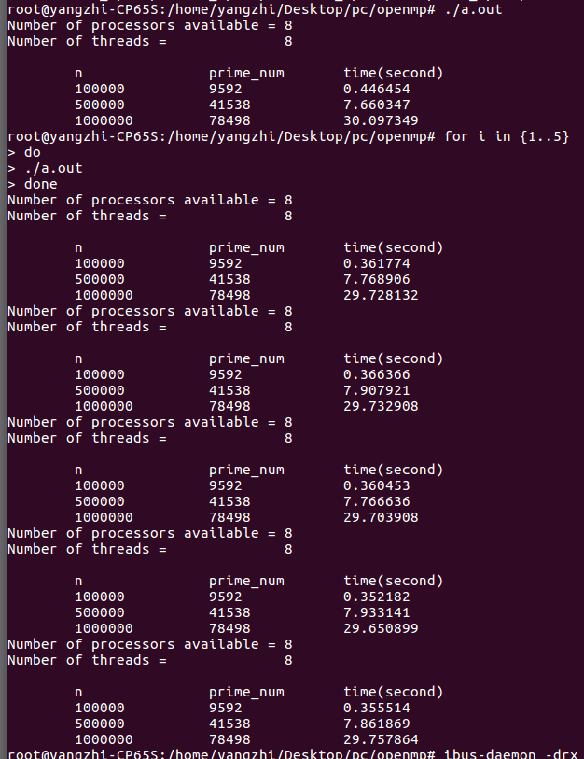

2 threads

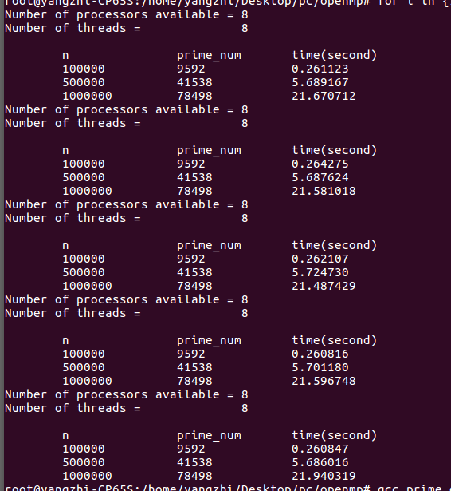

4 threads

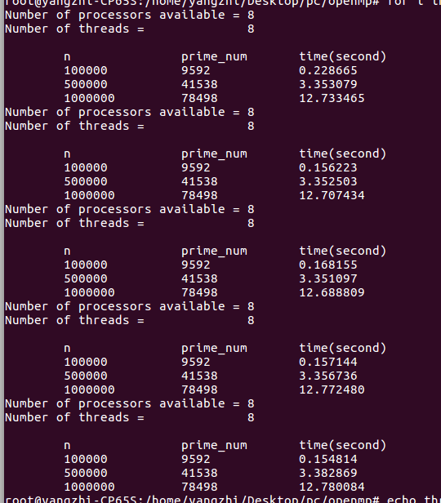

8 threads

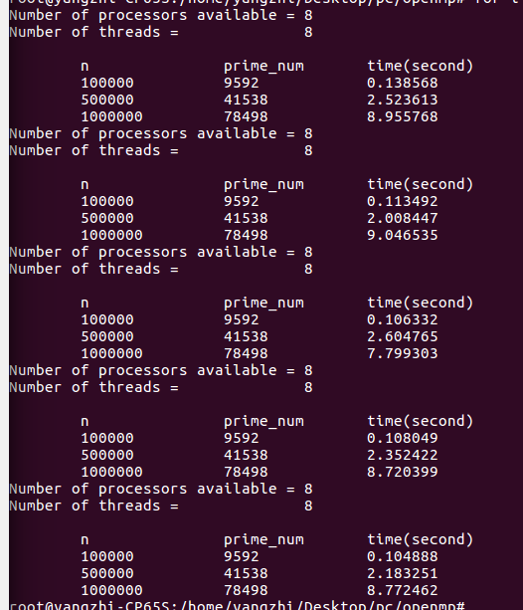

cell automata

1 thread

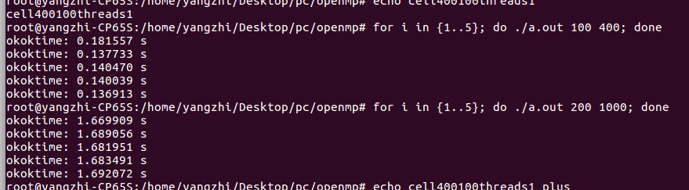

2 threads

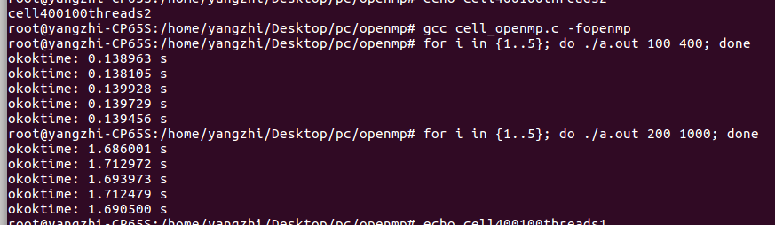

4 threads

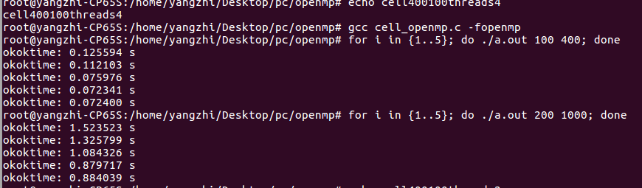

8 threads

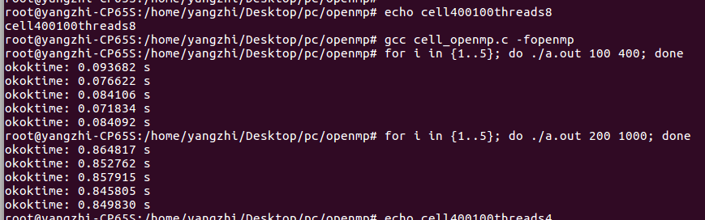

plus:

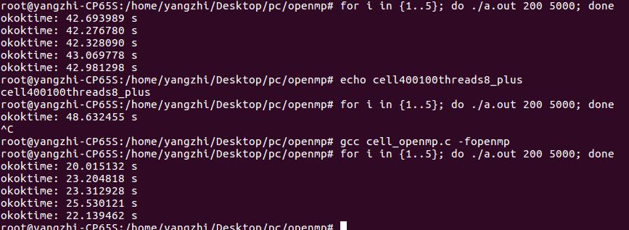

matrix multiplication

1 thread

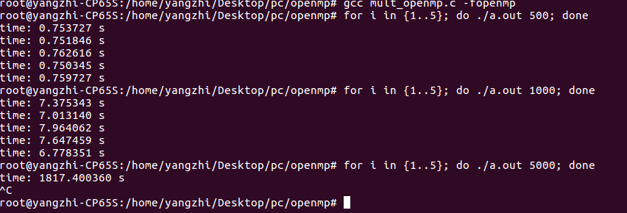

2 threads

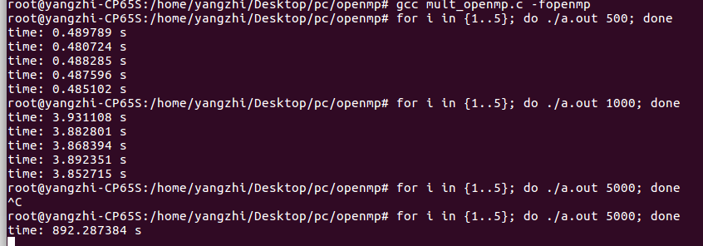

4 threads

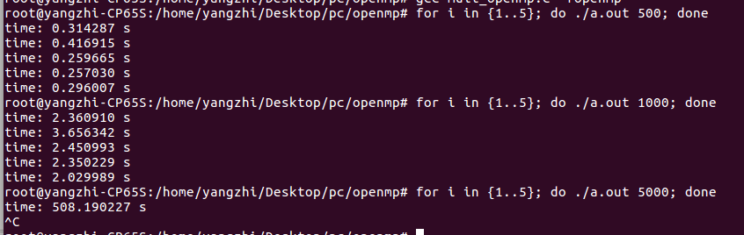

8 threads

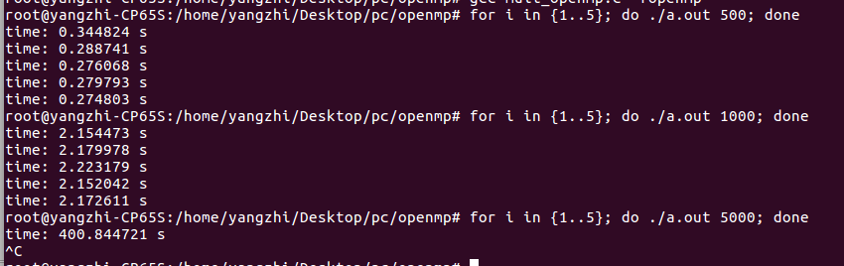

LU fatrorize

1 thread

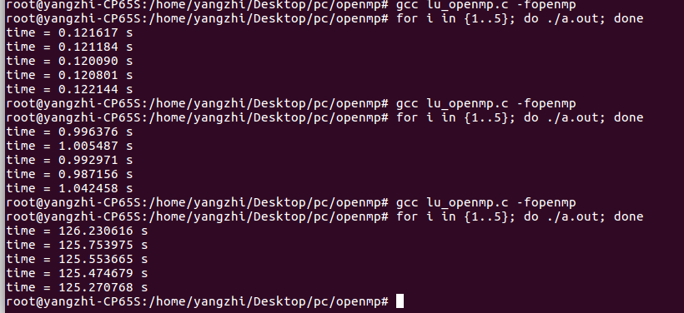

2 threads

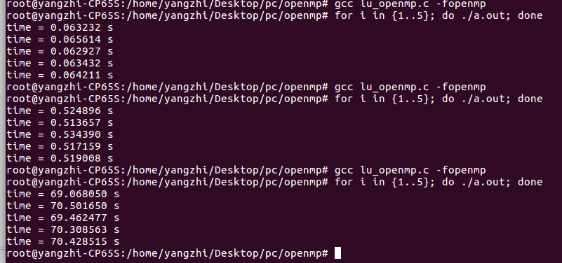

4 threads

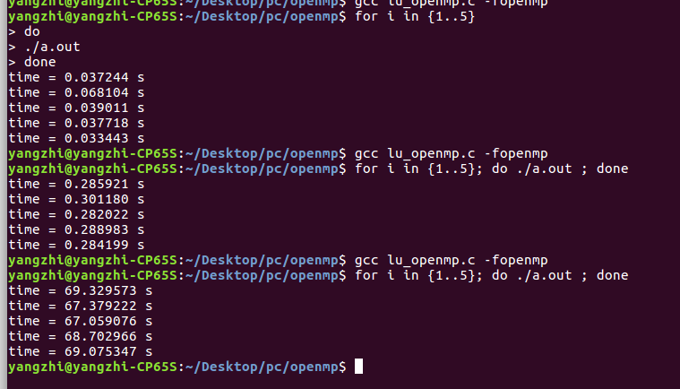

8 threads

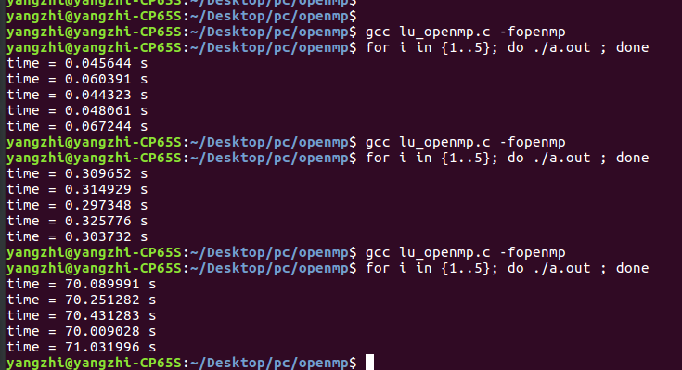

CUDA

prime_number

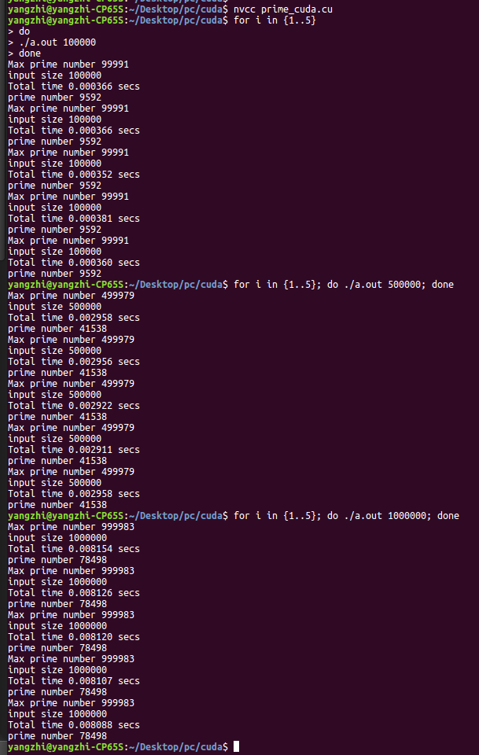

cell automata

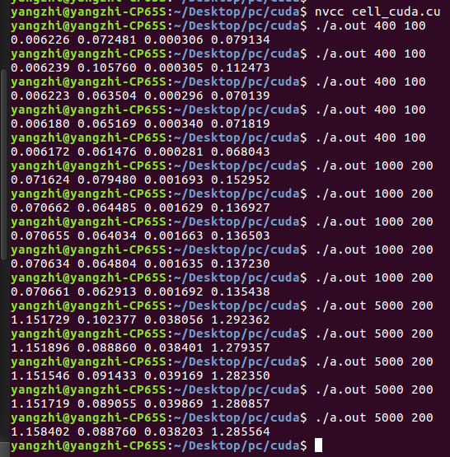

matrix multiplication

yangzhi@yangzhi-CP65S:~/Desktop/pc/cuda$ for i in {1..5}; do ./a.out 500; done

sequential matrix multiplication: 0.410527sec

parallel matrix multiplication without using Tiles: 0.067675sec

parallel matrix multiplication using Tiles: 0.00512sec

speedup without using Tiles: 6.06615

speedup using Tiles: 80.1811

check parallel result without using Tiles:

the sequential result and parallel result are equal

check parallel result using Tiles:

the sequential result and parallel result are equal

sequential matrix multiplication: 0.38543sec

parallel matrix multiplication without using Tiles: 0.066485sec

parallel matrix multiplication using Tiles: 0.005193sec

speedup without using Tiles: 5.79725

speedup using Tiles: 74.2211

check parallel result without using Tiles:

the sequential result and parallel result are equal

check parallel result using Tiles:

the sequential result and parallel result are equal

sequential matrix multiplication: 0.385542sec

parallel matrix multiplication without using Tiles: 0.066248sec

parallel matrix multiplication using Tiles: 0.005183sec

speedup without using Tiles: 5.81968

speedup using Tiles: 74.3859

check parallel result without using Tiles:

the sequential result and parallel result are equal

check parallel result using Tiles:

the sequential result and parallel result are equal

sequential matrix multiplication: 0.38589sec

parallel matrix multiplication without using Tiles: 0.065829sec

parallel matrix multiplication using Tiles: 0.005184sec

speedup without using Tiles: 5.86201

speedup using Tiles: 74.4387

check parallel result without using Tiles:

the sequential result and parallel result are equal

check parallel result using Tiles:

the sequential result and parallel result are equal

sequential matrix multiplication: 0.396794sec

parallel matrix multiplication without using Tiles: 0.06636sec

parallel matrix multiplication using Tiles: 0.005124sec

speedup without using Tiles: 5.97942

speedup using Tiles: 77.4383

check parallel result without using Tiles:

the sequential result and parallel result are equal

check parallel result using Tiles:

the sequential result and parallel result are equal

yangzhi@yangzhi-CP65S:~/Desktop/pc/cuda$ for i in {1..5}; do ./a.out 1000; done

sequential matrix multiplication: 3.11095sec

parallel matrix multiplication without using Tiles: 0.105837sec

parallel matrix multiplication using Tiles: 0.036715sec

speedup without using Tiles: 29.3938

speedup using Tiles: 84.7325

check parallel result without using Tiles:

the sequential result and parallel result are equal

check parallel result using Tiles:

the sequential result and parallel result are equal

sequential matrix multiplication: 3.04812sec

parallel matrix multiplication without using Tiles: 0.093727sec

parallel matrix multiplication using Tiles: 0.038376sec

speedup without using Tiles: 32.5212

speedup using Tiles: 79.4277

check parallel result without using Tiles:

the sequential result and parallel result are equal

check parallel result using Tiles:

the sequential result and parallel result are equal

sequential matrix multiplication: 3.15009sec

parallel matrix multiplication without using Tiles: 0.094051sec

parallel matrix multiplication using Tiles: 0.036795sec

speedup without using Tiles: 33.4934

speedup using Tiles: 85.6118

check parallel result without using Tiles:

the sequential result and parallel result are equal

check parallel result using Tiles:

the sequential result and parallel result are equal

sequential matrix multiplication: 3.16158sec

parallel matrix multiplication without using Tiles: 0.093972sec

parallel matrix multiplication using Tiles: 0.036678sec

speedup without using Tiles: 33.6439

speedup using Tiles: 86.1983

check parallel result without using Tiles:

the sequential result and parallel result are equal

check parallel result using Tiles:

the sequential result and parallel result are equal

sequential matrix multiplication: 3.10774sec

parallel matrix multiplication without using Tiles: 0.093633sec

parallel matrix multiplication using Tiles: 0.036669sec

speedup without using Tiles: 33.1907

speedup using Tiles: 84.7512

check parallel result without using Tiles:

the sequential result and parallel result are equal

check parallel result using Tiles:

the sequential result and parallel result are equal

yangzhi@yangzhi-CP65S:~/Desktop/pc/cuda$ for i in {1..5}; do ./a.out 5000; done

^C

yangzhi@yangzhi-CP65S:~/Desktop/pc/cuda$ nvcc mult_cuda.cu

mult_cuda.cu(162): warning: variable "elapsedsequential" was declared but never referenced

mult_cuda.cu(162): warning: variable "optimizationP" was declared but never referenced

mult_cuda.cu(162): warning: variable "optimizationT" was declared but never referenced

mult_cuda.cu(162): warning: variable "elapsedsequential" was declared but never referenced

mult_cuda.cu(162): warning: variable "optimizationP" was declared but never referenced

mult_cuda.cu(162): warning: variable "optimizationT" was declared but never referenced

yangzhi@yangzhi-CP65S:~/Desktop/pc/cuda$ for i in {1..5}; do ./a.out 5000; done

parallel matrix multiplication without using Tiles: 3.339sec

parallel matrix multiplication using Tiles: 3.28648sec

parallel matrix multiplication without using Tiles: 3.33834sec

parallel matrix multiplication using Tiles: 3.27242sec

parallel matrix multiplication without using Tiles: 3.34364sec

parallel matrix multiplication using Tiles: 3.28701sec

parallel matrix multiplication without using Tiles: 3.33857sec

parallel matrix multiplication using Tiles: 3.27249sec

parallel matrix multiplication without using Tiles: 3.34113sec

parallel matrix multiplication using Tiles: 3.28357sec

LU decomposition

